Overall Design is great. However, there are still some things that need to be added. Right now, it looks more like a portfolio website, which I could easily create using Google Sites. It would be good to include more company details, credibility elements, and information that makes the business look legitimate and professional. Green one is good to go.
Check the red TEXT in this documents for each page and add them accordingly. Thanks

- Home page
Intro
Headline: Your Trusted Sourcing Partner in China
We simplify global sourcing. Find reliable suppliers, ensure perfect quality, and deliver to your doorstep with complete peace of mind.
WE SOURCE
YOU GROW

Intro: (ADD)
Novious Global is based in Shanghai, China. We provide end-to-end sourcing solutions for global buyers and connect them with verified Chinese manufacturers. Our diverse team of international and Chinese experts brings strong communication skills, local market knowledge, and cross-cultural business understanding to ensure smooth and reliable sourcing. We offer one-stop sourcing solutions for startups, e-commerce sellers, retail chains, wholesalers, and B2B companies. With a strong and trusted network of manufacturers across China, we simplify the entire sourcing process, from product discovery and supplier selection to quality control and final delivery, providing complete peace of mind.
Add intro at least something like below ( 10 years of experience too)
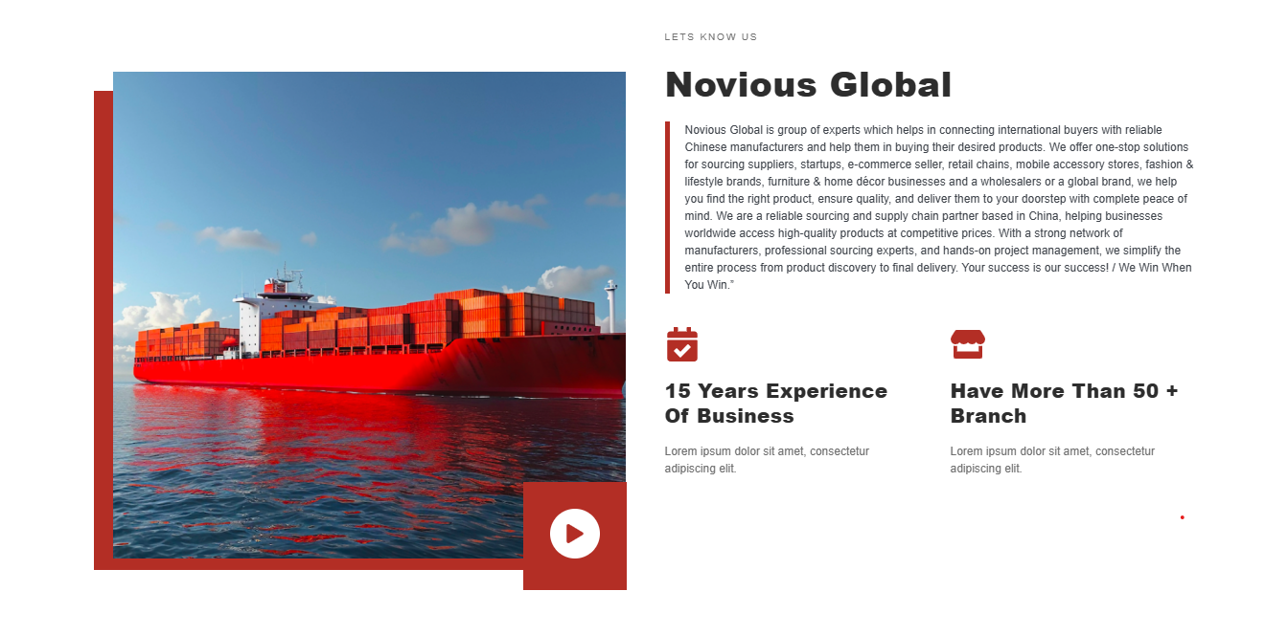

WHAT WE DO
We help businesses source quality products from China by connecting them with verified manufacturers. From supplier selection and quality control to logistics and delivery, we manage the entire sourcing process under one roof.
Supplier Verification & Quality Assurance
Shipping Solution
OEM/ODM solution
Product Sourcing

HOW WE WORK
Share your requirements with us, and our team will identify suitable suppliers, negotiate pricing, verify quality, and coordinate production. We keep you informed at every stage and ensure a smooth sourcing experience from start to finish.
Note: if you think these boxes will look weird in mobile version then prepare first then add designed image of these in the website but make sure pictures quality is better and align with design.
Shipping
Freight booking, Shipment scheduling, Export documentation (Invoice, Packing List, B/L).
Quality Control & Inspection
Product quality inspection and Pre-shipment inspection etc.

Negotiation & Contract Support
Identifying negotiation objectives (price, MOQ, lead time, delivery, warranty, quality, etc.)

Supplier Identification & Factory Visit
We identify and verify the most suitable factories, and provide transparent quotations.

Requirement Understanding & Consultation
We start by discussing your end goals, style preferences, budget, and material needs, etc.

Our Services
Product Sourcing
supplier identification, factory visit, negotiation, contract review, and quality control, risk mitigation

(
Global Shipping
Shipping route planning (sea, air, rail, express) Incoterms negotiation (FOB, TTP, CIF, EXW, DDP, etc.)

Project-Based B2B Solutions
Project Requirement
Supplier identification & Resource Allocation,
Quality Control
Delivery, & Post-Project Support
E-commerce Fulfillment Support
Shopify, Amazon, Etsy, WHATNOT, eBay and WooCommerce order fulfillment for
online sellers

Amazon Solutions
Private Label
Logistics &
FBA Fulfillment Support
Product Compliance
& Documentation

Why Choose Us
- Have 50 + Branch Office
Extensive Network in China as we have access to reliable companies across multiple industries, with full understanding Chinese business environment.
- 10+ years of experience in business
- Proven experience and expertise in handling diverse and complex projects for international clients.
- Extensive Network in China as we have access to reliable companies across multiple industries, with full understanding Chinese business environment.
- End-to-End Solutions: The sourcing solution and agreements to logistics and supervision, we cover the sourcing entire process.
- Trustworthy Partner: A client-first approach built on transparency, accountability, and long-term cooperation.

Package
Note: The prices shown are indicative; the final quotation will be provided after fully understanding your requirements. The general market standard is 3% if you already have a supplier, and 5% if you want us to find a supplier and manage the entire process for you. The percentage is calculated based on the total order value.
Starter Pack E-Commerce Sourcing All in One Project Base Service

- Initial meeting to understand project needs
- Provide visa invitation (if required)
- Accompany clients to visit suppliers
- Identify suitable factories
- Conduct factory visits
- Assist in meetings with suppliers
- Support price negotiation and contract finalization
- End-to-end project management: production, quality control, shipment, and delivery
- Post-project support and follow-up

- Initial meeting to understand Product/Project needs
- Product/ Market research
- Supplier identification & verification
- Factory Visit
- Provide Quotations
- Negotiation & Contracts
- Lead times, Payment Terms
- Supervise Production & Track Inspect Goods
- Pre-shipping inspection
- Shipping arrangements
- Consultancy

- Product sourcing
- Supplier/vendor verification
- Price negotiation and MOQ management
- Quotation collection
- Cost optimization
- Sample inspection and quality check
- Packaging and labeling
- Shipping arrangement

- Product sourcing from verified manufacturers
- Supplier/vendor outreach and identification
- Quotation collection and comparison
- Price negotiation support
- Basic sourcing consultancy
- Sample coordination and review

- Bold the headings of each package
- Link each package to WhatsApp
Reference: LIKE THIS ONE
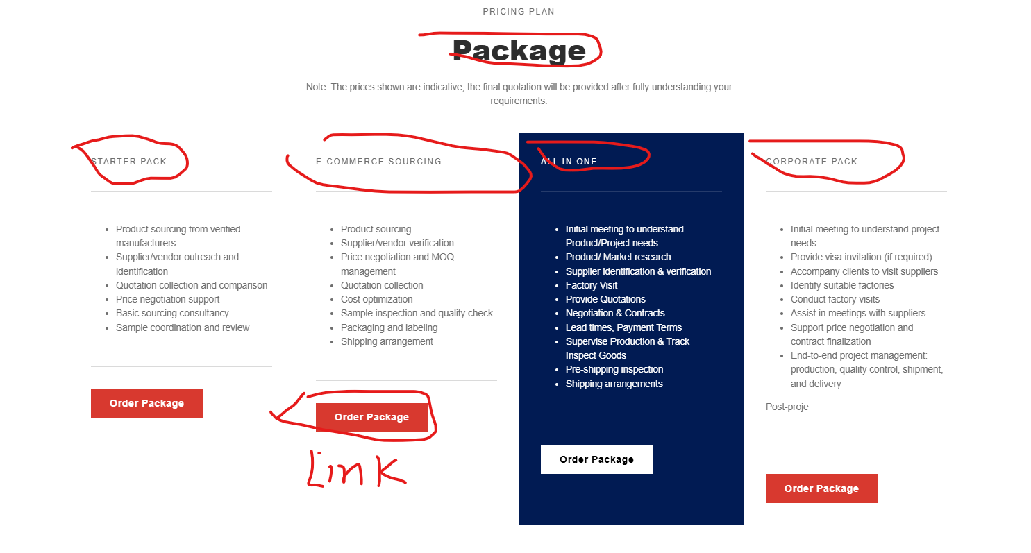

What Our Clients Say
John Peterson – CEO, Global Sports Co.
Working with Novious globe’s team has transformed our sourcing process. They identified reliable factories, helped with price negotiations, and ensured every product met our quality standards. Their hands-on approach made importing from China seamless and stress-free.
Hassam Ijaz – CEO REEM Fashion
The Novious global sourcing expertise in supplier verification and product sourcing was exceptional. Their professionalism and attention to detail made them a trusted partner for our fashion line.
Maria Gonzalez – Founder, EcoHome Supplies
The FBA and e-commerce support we received from Novious sourcing was outstanding. From sourcing to packaging and shipping, every step was professionally handled. Thanks to their guidance, our products reached Amazon warehouses on time and in perfect condition.
Liam Zhang – Operations Manager, BrightTech Solutions
We engaged them for a project-based service and were impressed with their level of detail. They accompanied us on factory visits, helped finalize contracts, and managed production and shipment efficiently. Truly a trustworthy partner for international sourcing.

Remove product feature from here or add in the end of the page keep a sequence, and structured flow
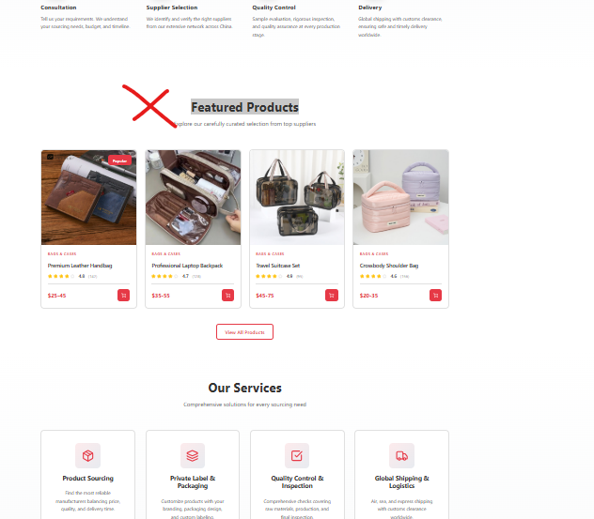

Note: This is just a reference But you need to add all the details on home page given above
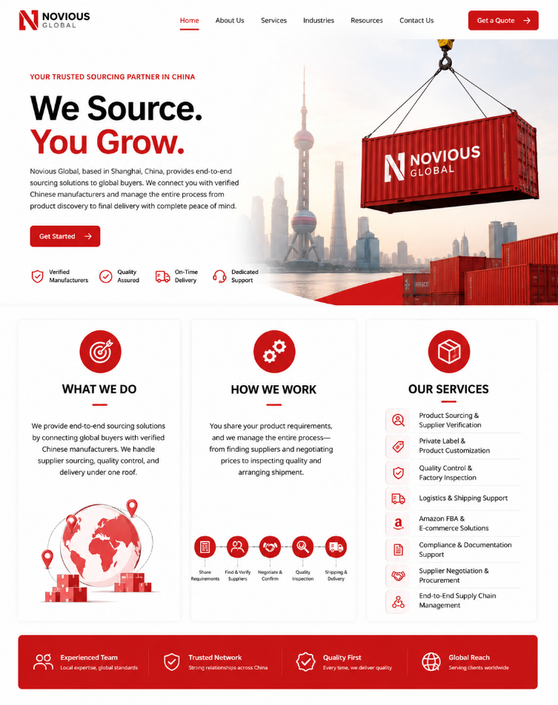

2- Products Preview Page

Products Content: Follow (https://jingsourcing.com/our-products/)

Remove prices
You have used one image in each products category (e.g below image)
1-（4-6 different product picture for each category and Use correct name）
2- Note: You can find the too many products names from the earlier word document to search and find high resolution picture.
3- Follow the categories structure as below
- Clothing and textile (Change the Name Garments and Home textile: add combo of pictures)
- Shoes and watches
- Bags and cases (men, women, kids, traveling purse, lady bag etc)
- Sports (Pic;wear and training equipment’s)
- Jewlllery
- Packaging ( different packing e.g pizza, disposable plats etc)
- Kitchen (+décor e.g lamp etc)
- Electronics
- Lights & Lighting
- Hardware Tools
- Toys
- Lithium Batteries

For example, below picture shows only one type of shirt with same design is use, please use different seasonal shirts both for male & female in different styles)
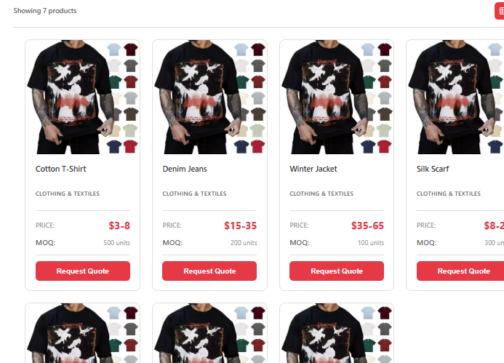

3. Business Strategy
Digital & internationalization business Strategy for Chinese Businesses to Go Global
We empower Chinese manufacturers, exporters, and entrepreneurs to go global with confidence. As both strategic advisor and hands-on experience, we deliver a dual-pronged approach: a modern digital strategy plus a robust business strategy. In today’s world, having a global footprint means engaging billions online over 5.56 billion people use the internet. We leverage this connectivity to boost your brand and sales overseas. Whether you’re a manufacturer, trader, or building a personal brand, our services are tailored to your needs.
Digital Strategy to Expand Beyond Borders

Our digital strategy is built to put your brand at the center of the global market. We design and develop localized websites that showcase your products to international audiences, supported by a cohesive brand identity. We optimize SEO and content to ensure discoverability 73% of online experiences begin with a search engine. We also leverage targeted Google Ads and powerful social platforms: TikTok alone has 1.59 billion monthly users worldwide, while networks like Facebook, LinkedIn and Instagram help you connect with professional and consumer communities across regions. Our key digital service offerings include:
Our Services
We target high-potential markets with data-driven ads (by region, language, and interest) to drive qualified traffic and leads.
Analytics & Optimization Data-driven insights and continuous improvement. We track user behavior, sales performance, and campaign ROI to refine your strategy over time, maximizing your return on investment.
SEO & Content Marketing Keyword optimization and content creation. Since most customers start their search online, we optimize your website and content to rank highly in Google and other international search engines.
Social Media Management &
Paid Ad Campaigns
Facebook
Instagram
Tiktok
Google Ads
LinkedIn
Youtube Channel
Website Development
& Branding
Global-ready websites and consistent brand design. We ensure your site is multi-language, mobile-responsive, and reflects a modern global brand image.

Our Digital Partner
Logo

- Internationalization Strategy
Our Internationalization strategy services lay the groundwork for successful international expansion. We help Chinese companies find and vet the right overseas partners, whether distributors, collaboration or joint ventures to extend your reach. We assist with every step of the cooperation process (contracts, negotiation, compliance, logistics) to ensure a smooth market entry. Key business strategy services include:
Partner Sourcing & Alliances
Identify and connect with reliable international distributors, retailers, or joint-venture partners. Our research-driven approach and networks help bridge distances and establish strong business relationships.
Market Entry & Compliance
End-to-end support for entering new markets. We conduct market research, advise on legal and regulatory requirements, and handle logistics and documentation so you can focus on growth.
Localization Strategy
Product adaptation, localize strategy and regional compliance setup ensure that offerings are tailored to local market needs, and meet all regulatory requirements in target regions.

Local Business Partner

Logo: ALTUS

Logo: ZTTEK
Logo: Percentac energy

4. About Us Page
Reference: https://worryfree360.com/about-us/
Mission
To make sourcing from China simple, transparent, and reliable by connecting global businesses with verified suppliers and delivering trusted end-to-end sourcing solutions.
About Founder & CEO
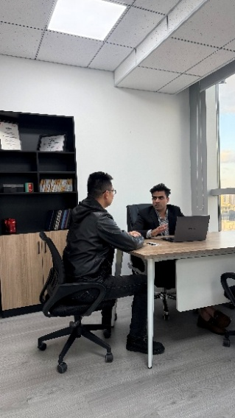
About Our Founder
Hamid is the visionary founder behind the company, with over 10 years of experience working directly with Chinese manufacturers across industries including consumer goods, garments, fashion accessories, energy, electronics, hardware, and construction. He learned Chinese language to broaden his local network and deep understanding of China business environment. Further, he completed his Master’s degree in International Trade and PhD in Business Management from Shanghai China. His unique blend of cross-cultural expertise, business knowledge, and hands-on industry experience enables him to build strong partnerships and deliver effective business solutions in the global market.
Our Story​​
Our story began in 2022 when Hamid, the founder of Novious Global, recognized the common challenges in sourcing faced by global buyers such as communication, supplier verification, and quality control, etc. So he founded this company in 2022 to provide a transparent, trustworthy, and efficient sourcing solution to connect global buyers with verified Chinese manufacturers and suppliers. He set out to build a company that would serve as a trustworthy partner for businesses worldwide. With a strong belief in integrity and client success, Hamid assembled a team of skilled professionals, both foreigners and Chinese, who shared his vision. Together, we built Novious Global on the principles of trust, quality, and end-to-end support. Today, we proudly help hundreds of clients streamline their sourcing process, reduce risks, and achieve their business goals. Your success is our greatest motivation, and we're committed to growing alongside you.
​ Our Story in Numbers
NOTE: It would be better to present these bullet points in a more visually appealing format. Like, graphical format, ICONS etc).
Since our founding in 2022, we take pride in the significant milestones we've reached while serving clients worldwide:
- ​​1000+ Satisfied Clients Globally​​ – Building trust across 30+ countries.
- ​​98% Client Retention Rate​​ – A testament to our reliable, quality-driven service.
- ​​Successfully Handled 1000+ Orders​​ – From sourcing to delivery, seamlessly.
- ​​Strategic Partnerships with 150+ Verified Suppliers​​ – Ensuring quality and competitive pricing.
- ​​​​These accomplishments reflect our dedication to being your trusted sourcing partner in China. Your trust drives us; your success defines us.

​​ ​
Partners (Logo images are provided check WhatsApp group)
4
3
2
1

Join Our Growing Family of International Clients​​
Whether you're a startup, e-commerce seller, or B2B company, Novious Global is here to make your China sourcing journey worry-free. Let us be your partners in growth and success. Let's build something great together.
​​Ready to experience stress-free sourcing from China? ​​
​​Contact us today to start your journey! ​​

ADD these pictures given Below (images I shared earlier) add 3 images here in the bottom

​​ 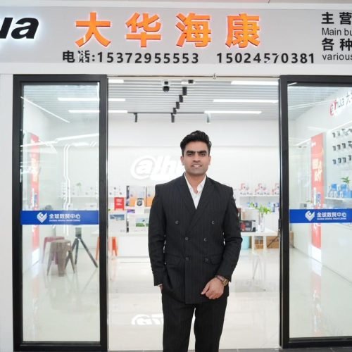 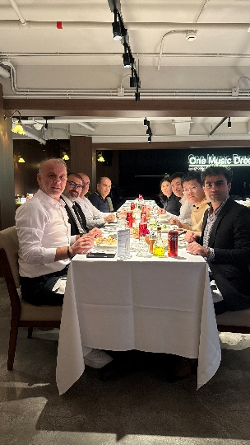

5-Blog Page

6-Contact Page

📍Address: ​​Head Office: ​​ Lotus Tower, No. 150 Tianzhou Road, Shanghai 200032, China
📧 ​​Email: ​​ info@noviousglobal.com
📞 ​​Phone: ​​ +86 15618483542
💬 ​​WhatsApp: ​​ +923077433743
🌐 ​​Web: ​​ noviousglobal.com

Social Media integration
Connect WhatsApp
Youtube: https://www.youtube.com/@NoviousGlobal
Instagram: https://www.instagram.com/chinasourcing_?igsh=OHN0NXdpNGxpcTBq&utm_source=qr
Facebook: https://www.facebook.com/noviousglobalsourcingchina
TikTok: www.tiktok.com/@novious.global.china
LinkedIn: https://www.linkedin.com/company/novious-global-sourcing-from-china/
1. What services do you offer for product sourcing?
We provide end-to-end product sourcing services, including supplier identification, factory verification, quotation collection, price negotiation, sample coordination, and quality inspection to help businesses source reliable products from China and other markets.
2. How do you ensure the quality of products from suppliers?
Our team performs pre-shipment inspections, in-process quality checks, and factory audits to ensure that every product meets your quality standards. We also assist in sample review and compliance verification before mass production.
3. Can you help with Amazon FBA or e-commerce fulfillment?
Yes! We offer specialized FBA and e-commerce solutions, including product sourcing, supplier verification, packaging and labeling guidance, shipping to Amazon warehouses, and logistics coordination to help online sellers streamline their operations.
4. Do you provide support for large or project-based sourcing?
Absolutely. Our Project-Based Services include personalized consultations, factory visits, supplier meetings, contract support, price negotiation, and end-to-end project management, ensuring smooth execution from production to shipment.
5. How do I get a quotation for my sourcing requirements?
You can share your project details with us through our contact form or consultation call. Once we understand your requirements, we provide a transparent quotation tailored to your product specifications, quantity, and sourcing complexity.

